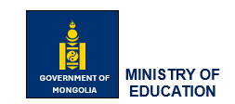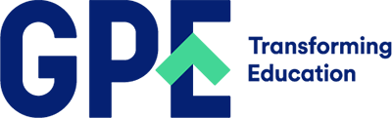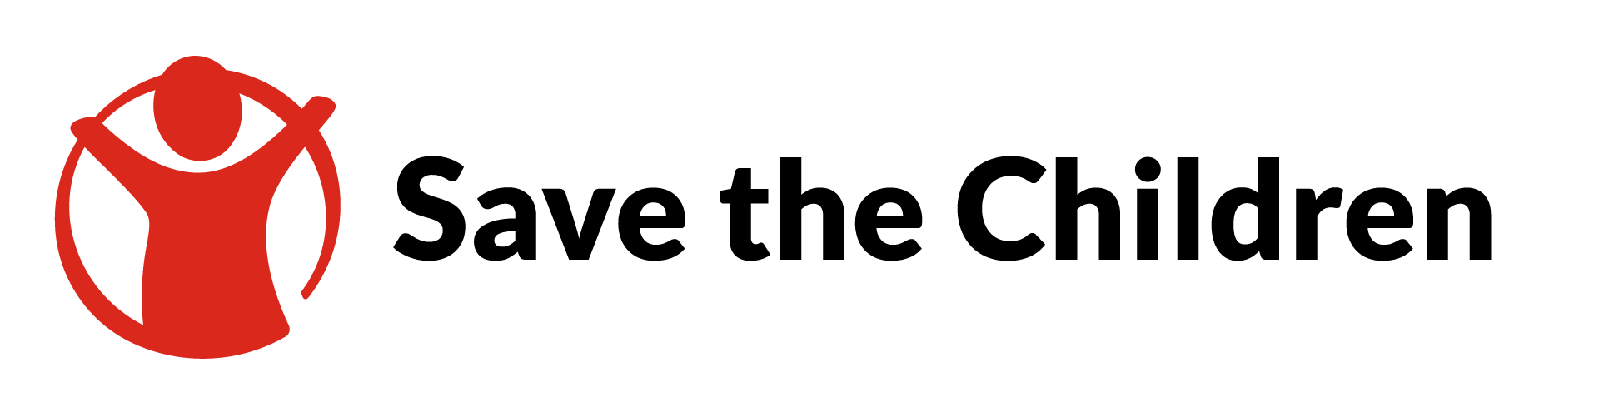

TERMS OF REFERENCE
for
ADMINISTRAION OFFICER
Title | Administration Officer of PIU
Duration | 12 months (full time)
Location | Ulaanbaatar, Mongolia
Reports to | Project Coordinator and Project Director, MES
Funded by: | GPE (Global Partnership for Education Project)

- BACKGROUND
The Global Partnership for Education (GPE), of which Mongolia is a partner, has adopted a new strategic plan for the period 2021-2025, entitled “GPE 2025.” In light of the education challenges that GPE partner countries face, particularly following the pandemic, this plan is an ambitious one and sets out the following goal: “to accelerate progress, learning outcomes and gender equality through equitable, inclusive and resilient education systems fit for the 21st century.” To implement the new plan, the GPE made the Education Sector Plan Implementation Grant (ESPIG) Multiplier Grant, dedicated to supporting the implementation of national Education Sector Plans accessible to certain countries to leverage additional external financing for education.

The Ministry of Education and Science (MES) of Mongolia applied for the GPE Multiplier Grant, intending to complement three projects respectively funded and implemented by the Japan International Cooperation Agency (JICA), Korean International Cooperation Agency (KOICA) and Save the Children (SC). These projects are strengthening school feeding as well as equity and inclusion within the education system in Mongolia. The Multiplier will also enable the MES and partners to address the need to recover from the learning loss caused by the COVID-19 pandemic.

In April 2021, the GPE Secretariat approved Mongolia’s expression of interest to access the GPE Multiplier allocation for US$ 5 million. In July 2021, with the backing of all Local Education Group partners, the MES selected Save the Children (SC) as the Grant Agent for this funding and the GPE Secretariat endorsed the MES selection the following month.

The project has three main components, which are described below:

Component 1: Inclusive education
The MES is strongly committed to ensuring that all children, especially children with special needs, have equal access to quality inclusive education. Within this component, it is aimed that access and quality of education for children with special needs are improved by strengthening the capacity of primary and secondary education teachers in public schools.

The Inclusive Education component will complement the ongoing teacher professional development program by further integrating inclusive pedagogy in-service teacher training courses and building the capacities of teachers on inclusive education in primary and secondary schools.

The funds from the GPE also will enable effective support to the implementation of related policies and regulations by allowing an increase of the scope of the current projects implemented by Save the Children and JICA and the involvement of more teachers from mainstream schools.

Component 2: School lunch
The proposed program would help to implement the Government Action Plan (2020-2024), which aims to increase the budget for student meals and transform primary and secondary schools' "School Snack" program into a "School Lunch Program." The proposed initiative will make a substantial contribution to enhancing access to education by improving food production and services within schools. It will also result in good improvements in students' eating habits, health, and well-being.

With the potential KOICA project aiming at primary and both lower and upper secondary, MES will be able to achieve its plan to provide students with safe, healthy and nutritious food. Through this project target schools will have a renovated and fully equipped meal service area and a Training Center for Dietitians and Chefs will be established at the Mongolian State University of Science and Technology. Other expected outputs include guidelines for school meal service management, enhanced capacity of school cooks and nutrition staff and improved awareness of stakeholders of the importance of healthy school meals.

Component 3: Blended Learning
The component on ‘Blended learning’ will support the MES to further mobilize the education partners to jointly design and implement a professional development program for education personnel and in-service teachers. The Teacher Professional Development program will improve teachers' classroom and online teaching methodologies, as well as their confidence in delivering blended learning.

To accelerate the education recovery, the MES wishes to prioritize blended learning, which is a combination of online instruction and self-paced learning with classroom teaching. This component will design a blended learning model, that will be piloted in primary and secondary schools (number to be determined). The integration of the blended learning model in school will enable learners to reconnect to the school environment and engage in a variety of learning opportunities inside and outside the classroom. In case of further school disruption and closure, such a blended learning model could be pivoted to a distance learning program, which will enable learning continuity.

The GPE Multiplier will act as a catalyst, and this component will build on and strengthen the ongoing distance education programs supported by education partners such as UNICEF and the World Bank.

- SCOPE of WORK
An administration officer is to undertake a variety of office support tasks working with a high degree of attention to detail and discretion, incorporating new and effective ways to achieve better results, and performing all administration and clerical tasks necessary for the project implementation unit. Their duties include budgeting, organizing company records and schedules, managing office inventory, and supporting to project team.
- DETAILED TASKS

- Organize the office and assist associates in ways that optimize procedures
- Sort and distribute communications on time
- Create and update records ensuring the accuracy and validity of information
- Schedule and plan meetings and appointments
- Monitor the level of supplies and handle shortages
- Resolve office-related malfunctions and respond to requests or issues
- Coordinate with others to ensure compliance with established policies
- Maintain trusting relationships with suppliers, customers/partners and colleagues
- Perform receptionist duties when needed
- Perform other duties as required.

- QUALIFICATIONS and EXPERIENCES

- Bachelor’s degree in foreign affairs and or any other relevant field. A Master’s degree and other advanced degrees will be advantageous.
- Strong communication skills in Mongolian and English
- Written and oral English proficiency
- Excellent time management skills and ability to multi-task and prioritize work
- Strong organizational and planning skills
- Effective telephone communication and customer service skills
- Extremely proficient with Microsoft Office software with an understanding of office equipment
- Have experience working as a government officer for a government agency, which will be advantageous.

- APPLICATION PROCESS
Interested individuals are requested to send his/her resume¹ and a cover letter² explaining the reasons for applying for the position, and describing how the candidate’s qualifications, skills, and work experiences meet the requirements of the job via email to coordinator.equalproject@gmail.com no later than Sep 25, 2024, 5 PM. We accept the application in PDF format.

Only the short-listed candidates will be contacted and asked to (i) take the translation and documentation short tests; (ii) have a job interview with the selection committee (iii) provide proof of work experience and original copies of diplomas and certificates at the interview.

ENABLING EQUITY TO ADVANCE LEARNING PROJECT

