Өгүүллийн Нэр
Өгүүллийн дэд нэр

Зохиогчийн нэр
Харъяа тэнхим, сургуулийн нэр
Их сургуулийн нэр
Хот, Улс Шуудангийн код
Цахим шуудангийн хаяг
Батбаярын Батбаяр
Эрчим Хүчний Сургууль
Шинжлэх Ухаан Технологийн Их Сургууль
Улаанбаатар хот, Монгол Улс 14191
batbayar@must.edu.mn

Хураангуй—Энэ хэсэгт өгүүллийн хураангуй бичнэ. (Энэ файл нь өгүүлэл бичих жишиг файл байгаад бичиглэлийн үндсэн талбар, гарчиг дэд гарчигнуудыг Heading1, Heading2 гэх мэт дэс дараатай ангилсан болно. Энэхүү жишиг загвар доторх ямар нэгэн форматыг дур мэдэн өөрчлөлгүй энэ файлд захирагдан өгүүллээ бичнэ үү, Navigation цэстэй ажиллавал илүү зохимжтой)
Түлхүүр үг—component; formatting; style; styling; insert (key words)

Оршил (Heading 1)
This template, modified in MS Word 2007 and saved as a “Word 97-2003 Document” for the PC, provides authors with most of the formatting specifications needed for preparing electronic versions of their papers.

Хоёрдугаар хэсэг

Дэд гарчиг (Heading 2)
First, confirm that you have the correct template for your paper size. This template has been tailored for output on

Дэд гарчиг
The template is used to format your paper and style the text. All margins, column widths, line spaces, and text fonts are prescribed;

Гуравдугаар хэсэг
Before you begin to format your paper, first write and save the content as a separate text file. Abbreviations and Acronyms

Дэд гарчиг
- Use either SI (MKS) or CGS as primary units. (SI units are encouraged.) English units may be used as secondary units (in parentheses). An exception would be the use of English units as identifiers in trade, such as “3.5-inch disk drive.”
- Avoid combining SI and CGS units, such as current in amperes and magnetic field in oersteds. This often leads to confusion because equations do not balance dimensionally. If you must use mixed units, clearly state the units for each quantity that you use in an equation.
- Do not mix complete spellings and abbreviations of units: “Wb/m2” or “webers per square meter,” not “webers/m2.” Spell units when they appear in text: “...a few henries,” not “...a few H.”
- Use a zero before decimal points: “0.25,” not “.25.” Use “cm3,” not “cc.” (bullet list)
Өгүүллийг санхүүжүүлсэн грантын нэр

Томъёо
Томъёог дараах байдлаар дугаарлана уу
a  b             

Эшлэл
Эшлэлийг дараах байдлаар тэгш өнцөгт хаалтанд дэс дараалан өгүүлэлд дурьдана [1].

Дөрөвдүгээр хэсэг
After the text edit has been completed, the paper is ready for the template. Duplicate the template file by using the Save As command, and use the naming convention prescribed by your conference for the name of your paper. In this newly created file, highlight all of the contents and import your prepared text file. You are now ready to style your paper; use the scroll down window on the left of the MS Word Formatting toolbar.

Зураг болон хүснэгтийн жишиг загвар болон дугаарлалт
- Table Styles
Table Head | Table Column Head
Table Head | Table column subhead | Subhead | Subhead
copy | More table copyª
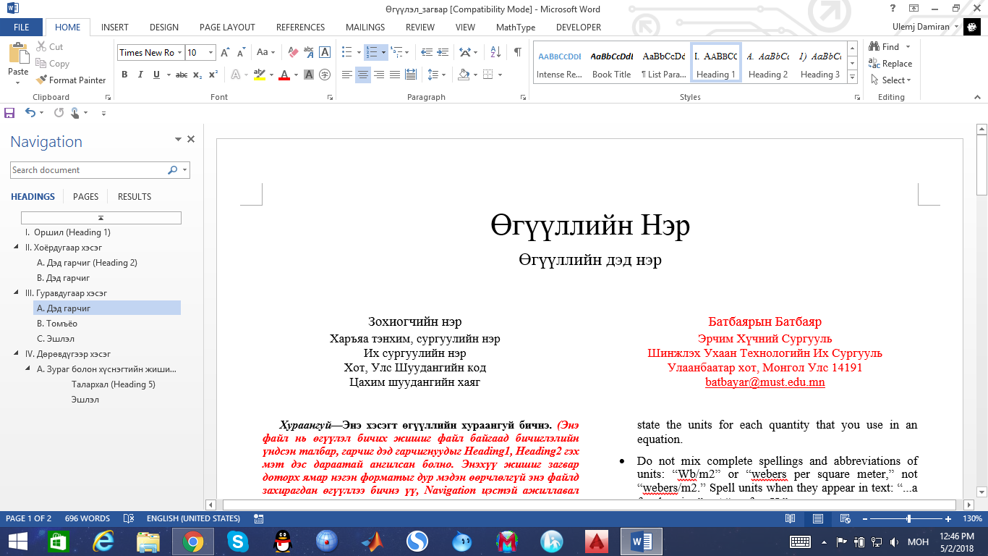
- Example of a figure caption. (figure caption)

Талархал (Heading 5)
The preferred spelling of the word “acknowledgment” in America is without an “e” after the “g.” Avoid the stilted expression “one of us (R. B. G.) thanks ...”. Instead, try “R. B. G. thanks...”. Put sponsor acknowledgments in the unnumbered footnote on the first page.

Эшлэл
- G. Eason, B. Noble, and I.N. Sneddon, “On certain integrals of Lipschitz-Hankel type involving products of Bessel functions,” Phil. Trans. Roy. Soc. London, vol. A247, pp. 529-551, April 1955. (references)
- J. Clerk Maxwell, A Treatise on Electricity and Magnetism, 3rd ed., vol. 2. Oxford: Clarendon, 1892, pp.68-73.
- I.S. Jacobs and C.P. Bean, “Fine particles, thin films and exchange anisotropy,” in Magnetism, vol. III, G.T. Rado and H. Suhl, Eds. New York: Academic, 1963, pp. 271-350.
- K. Elissa, “Title of paper if known,” unpublished.
- R. Nicole, “Title of paper with only first word capitalized,” J. Name Stand. Abbrev., in press.
- Y. Yorozu, M. Hirano, K. Oka, and Y. Tagawa, “Electron spectroscopy studies on magneto-optical media and plastic substrate interface,” IEEE Transl. J. Magn. Japan, vol. 2, pp. 740-741, August 1987 [Digests 9th Annual Conf. Magnetics Japan, p. 301, 1982].
- M. Young, The Technical Writer’s Handbook. Mill Valley, CA: University Science, 1989.

