REMINDER:
- Write down the title of the passage as well as the date of the day, and make sure to answer with full sentences on your NOTEBOOK.
- Look for the new words from the dictionary, and create 1 correct sentence.
- Notebooks will be taken once school starts.
- Future grades will be determined by how you have completed your homework. So, MAKE SURE you do your homework!
First week
Read the passage below and answer the questions.
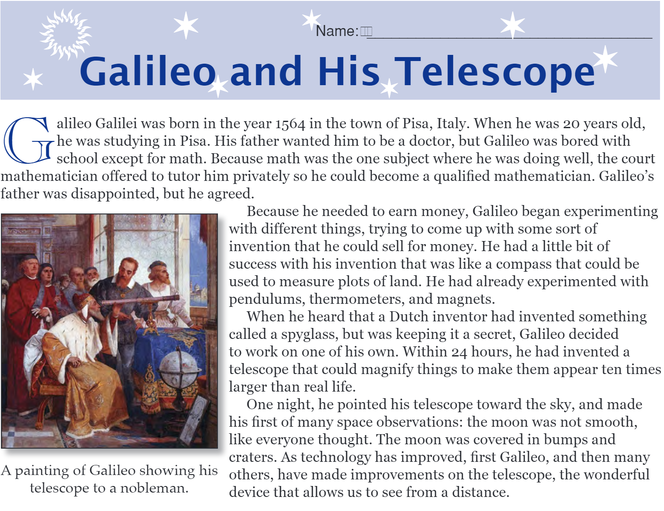
Questions to answer.
- Why did the court mathematician teach him math?
- What was the compass that Galileo created used for?
- According to his observations of the moon, what did it look like?
New words:
- Experiment-
- Magnify-
- Observation-
- Crater-
- Telescope-
Second Week
Read the passage below and answer the questions.
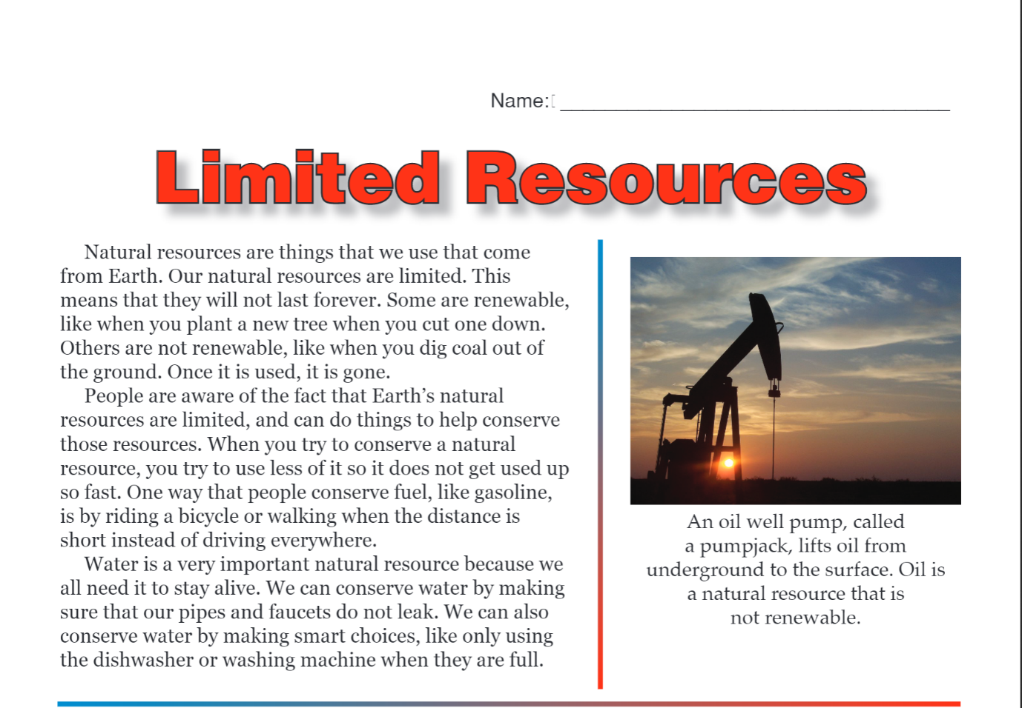
Questions to answer.
- What are examples of renewable resources?
- How can we conserve natural resources?
- What is one of the most important natural resource that we need to conserve?
New words:
- Renewable-
- Coal-
- Natural resource-
- Conserve-
- Pipes-
- Faucet-

Third week
Read the passage below and answer the questions.
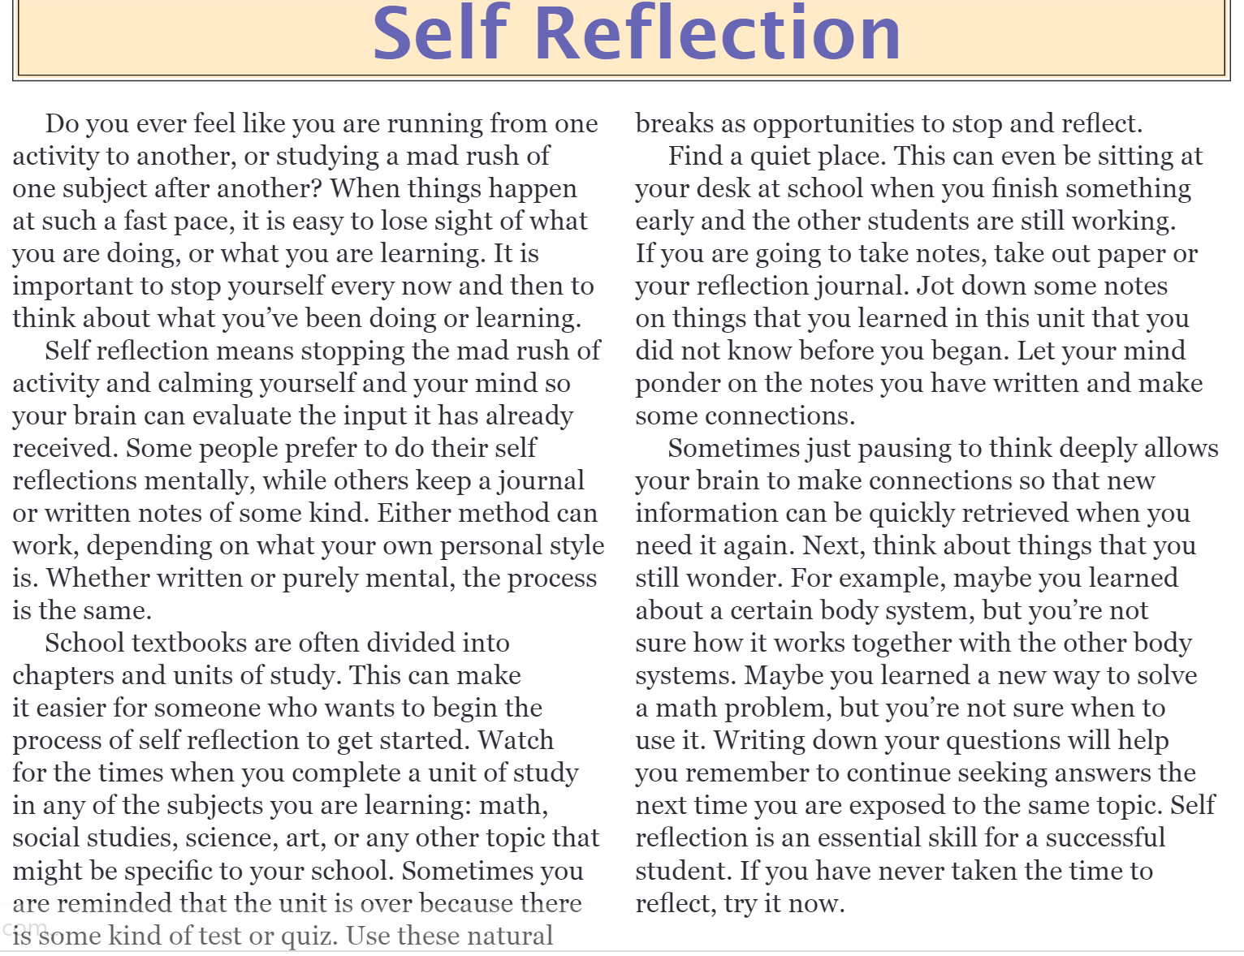
Questions to answer.
- What is self-reflection?
- According to the passage, what can you do to self-reflect?
New words.
- Evaluate-
- Input-
- Specific-
- Retrieve-
- Expose-
- Essential-

Fourth week
Read the passage below and answer the questions.
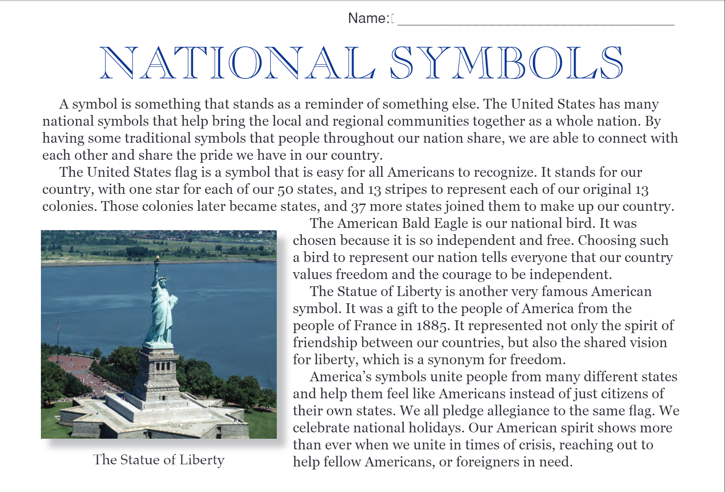
Questions to answer.
- What is a symbol, and why is it important to have traditional symbols?
- Why did the Bald Eagle become the national bird of the USA?
- What country in which year gave the Statue of Liberty to the USA as a gift?
- What is the national symbol of Mongolia?
New words.
- Symbol
- Represent
- Synonym
- Crisis
- Vision

