REMINDER:
- Write down the title of the passage as well as the date of the day, and make sure to answer with full sentences on your NOTEBOOK.
- Look for the new words from the dictionary, and create 1 correct sentence.
- Notebooks will be taken once school starts.
- Future grades will be determined by how you have completed your homework. So, MAKE SURE you do your homework!
First week.
Read the passage below and answer the questions.
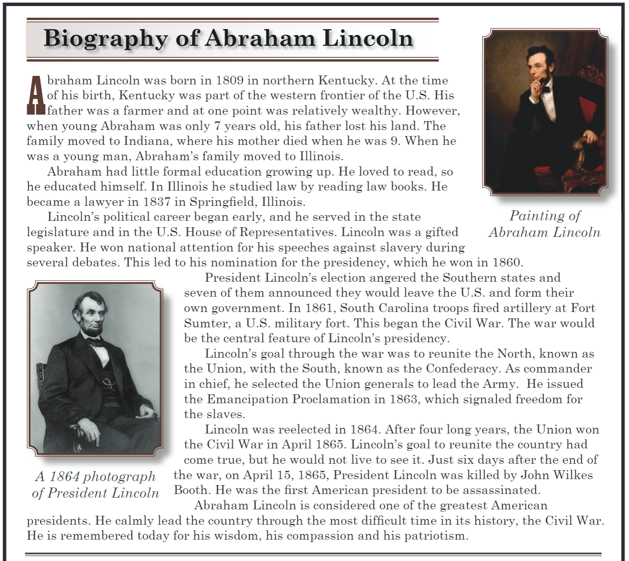
Questions to answer.
- Did Abraham Lincoln’s formal education affect him becoming a lawyer?
- What led to his nomination for the presidency?
- Why did the Civil War begin?
- What was his main goal during his presidency?
- What was the Emancipation Proclamation about?

New words.
- Frontier
- Legislature
- Debate
- Patriotism

Second week
Read the passage below and answer the questions.
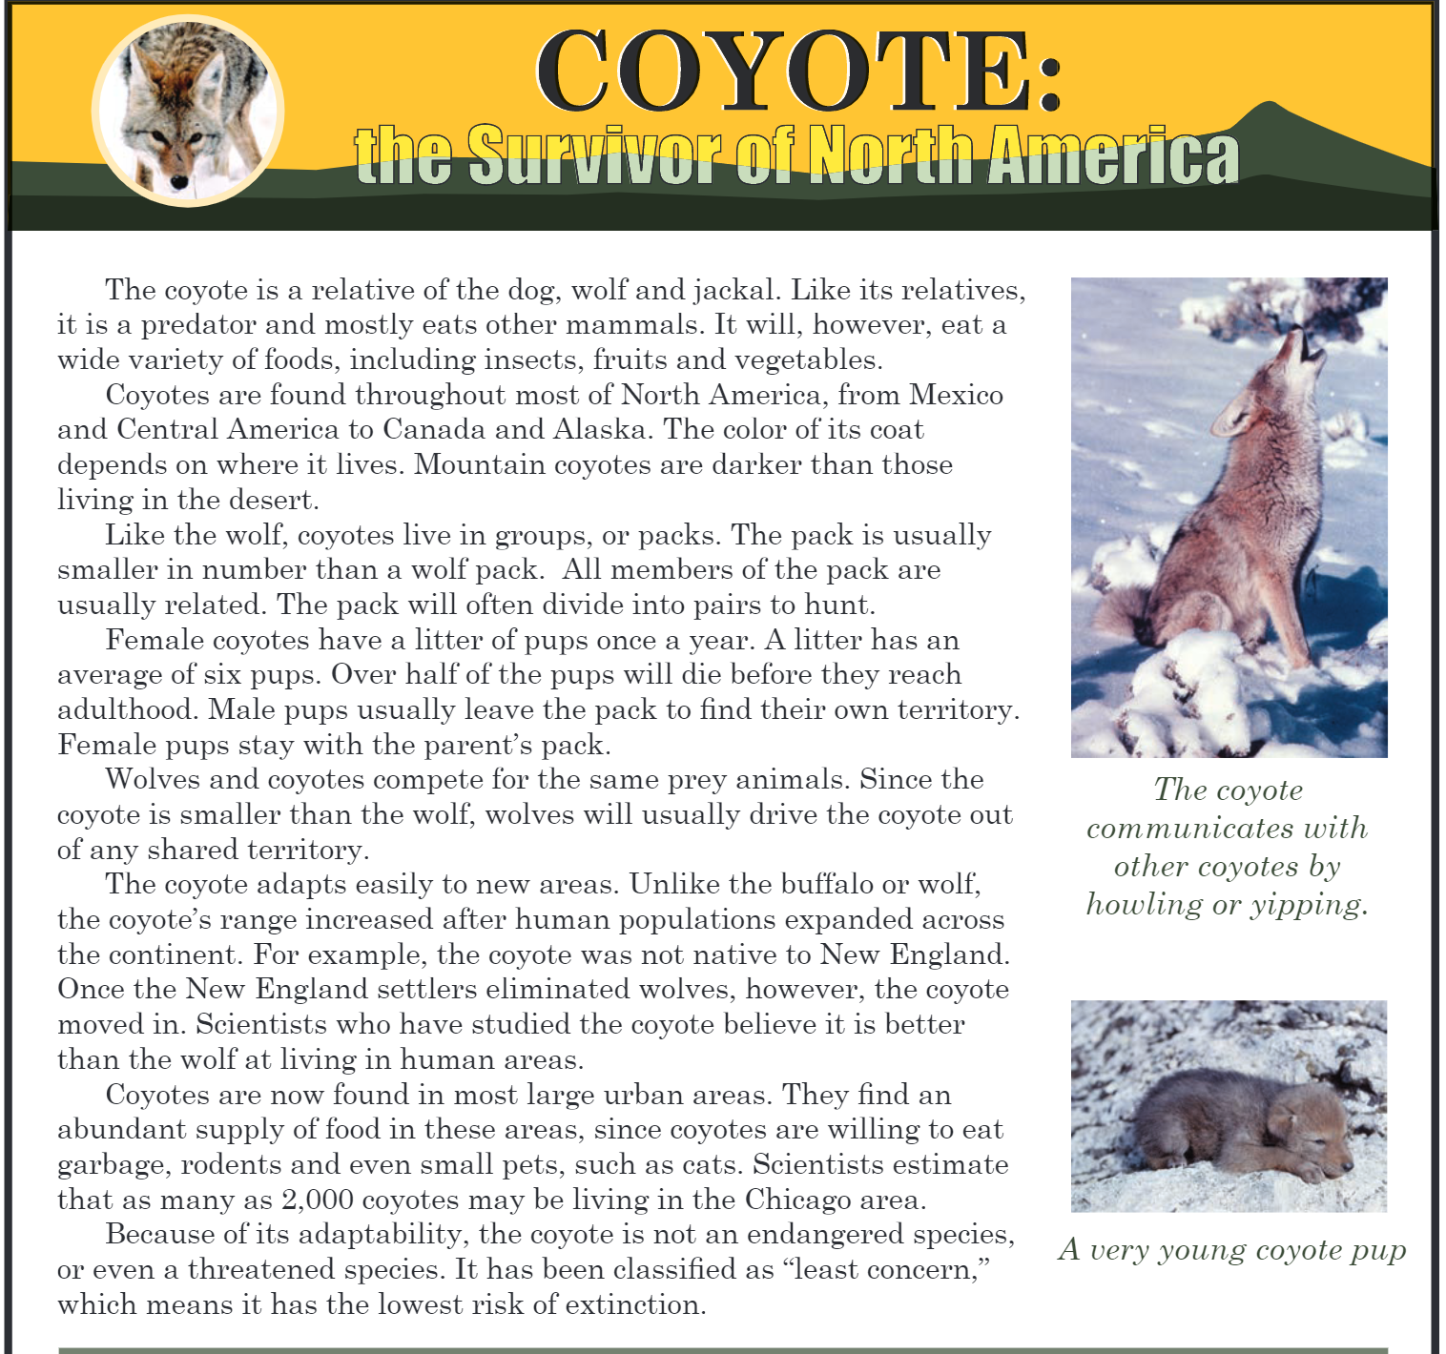
Questions to answer.
- What does the color of a coyote’s coat depend on? Write examples.
- How does the pack hunt?
- Why do male pups leave the pack?
- Why did the coyote’s range increase?
New words.
- Predator
- Prey
- Adaptability
- Eliminate
- Extinction

Third week
Read the passage below and answer the questions.
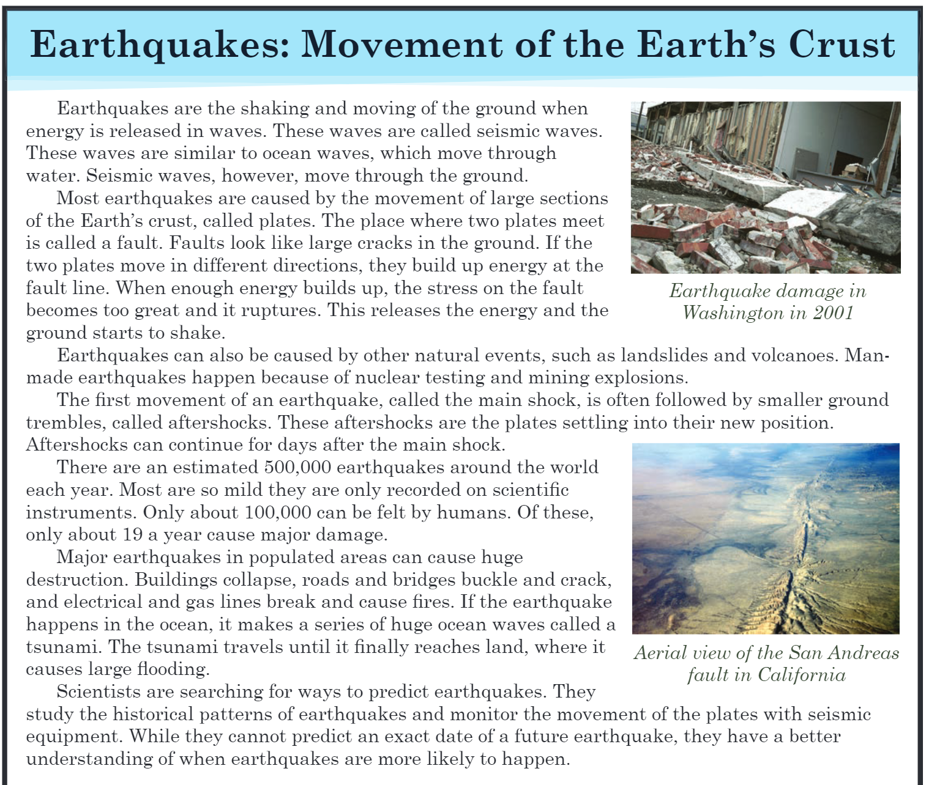
Questions to answer.
- According to the passage, when does the ground start to shake?
- What other natural events cause earthquakes?
- What are aftershocks?
- How do scientists predict earthquakes?
New words.
- Rupture
- Estimate
- Destruction
- Predict
- Nuclear

Fourth week
Read the passage below and answer the questions.
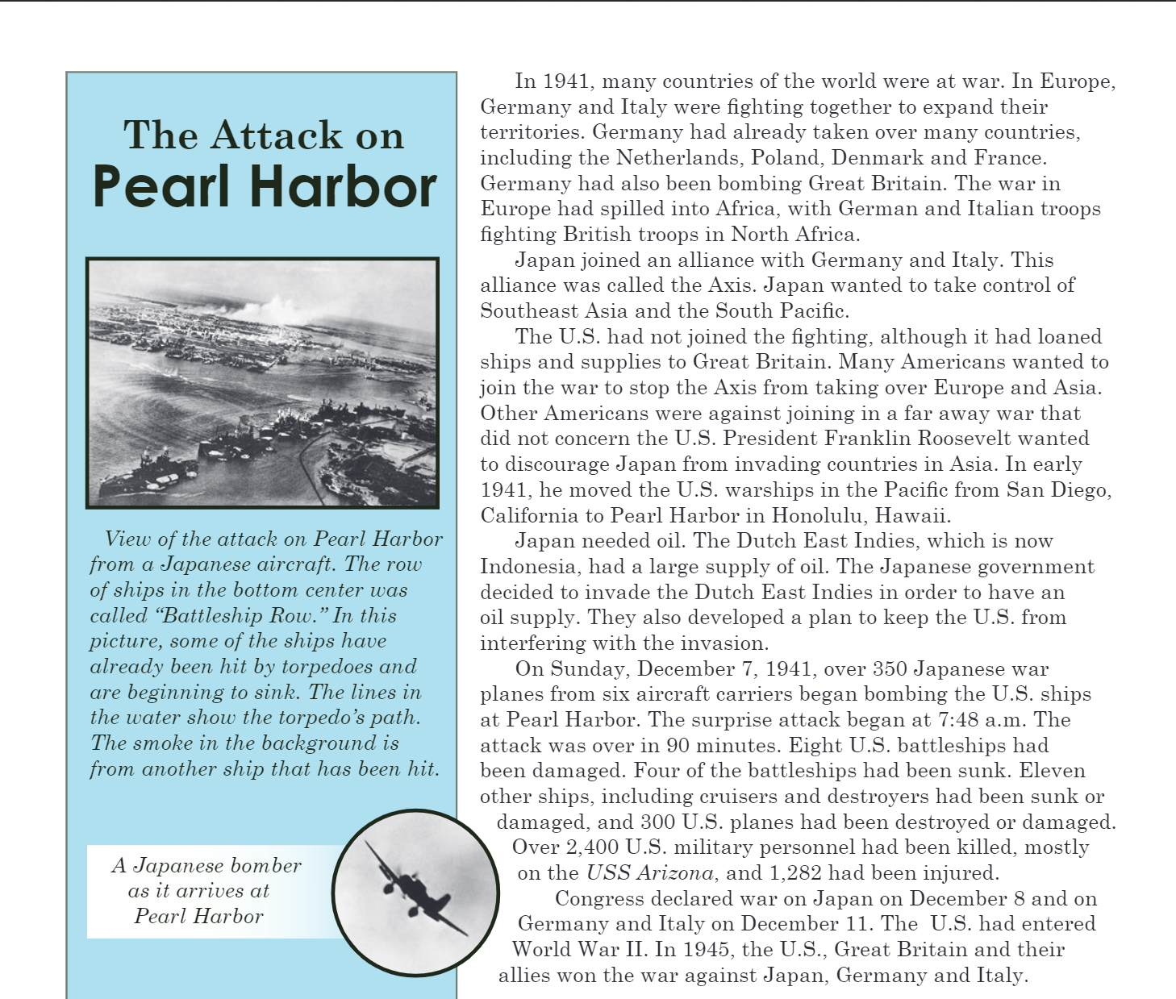
Questions to answer.
- Why were Germany and Italy fighting together?
- Why did Japan join Germany and Italy?
- Why did Japan attack Pearl Harbor?
- What led the USA to enter World War II?
New words.
- Alliance
- Invade
- Interfere
- Personnel
- Declare

