REMINDER:
- Write down the whole exercise when you are doing it. Make sure to write down the date.
- Notebooks will be taken once school starts.
- Future grades will be determined by how you have completed your homework. So, MAKE SURE you do your homework!
First week
Participle Adjectives UNIT 85.
Exercise 1. Choose the correct participle adjective.
- My nephew was_____(amused/amusing) by the clown.
- It’s so_____(frustrated/frustrating)! No matter how much I study I can’t seem to remember this vocabulary.
- This movie is so_____(bored/boring).
- I’m feeling_____(depressed/depressing), so I’m going to go home, eat some chocolate, and go to bed early with a good book.
- I though her idea was absolutely________(fascinated/fascinating)
- This math’s problem is________(confused/confusing)! Can you help me?
- The teacher was really_______(amused/amusing), so the lesson passed quickly.
- The journey was______(exhausted/exhausting)! Twelve hours by bus!
- The plane began to move in a rather________(alarmed/alarming) way.
- He was_______(frightened/frightening) when he saw the spider.
- I was really_______(embarrassed/embarrassing when I fell over in the street.
- That film was so_______(depressed/depressing)! There was no happy ending for any of the characters.
- I’m sorry, I can’t come tonight. I’m completely_________(exhausted/exhausting)
- We are going in a helicopter? How______(excited/exciting)!
- Don’t show my baby photos to people, Mom! It’s so_____(embarrassed/embarrassing)
- It’s okay, it’s only me. Don’t be______(alarmed/alarming)
- My sister is so________(excited/exciting) because she is going on holiday tomorrow.
- I hate long flights. I’m always really________(tired/tiring)
- She looked very______(confused/confusing) when I told her we had to change the plan.
- John was_______(fascinated/fascinating) by Mandarin when he started learning.
Exercise 2. Choose the correct compound adjective from below.
Deeply-rooted brand-new well-mannered old-fashioned short-sighted
- When Brian got his promotion, he bought a_________car.
- Look at Leila. She’s wearing an__________skirt. She found it in her grandmother’s drawer.
- Nancy is such a _________girl. She can’t even read what’s on the blackboard.
- Some people think that we should preserve the________traditions of countries.
- Cathy is a _______girl. She’s very polite.

Second week
Prepositions after adjectives UNIT 86
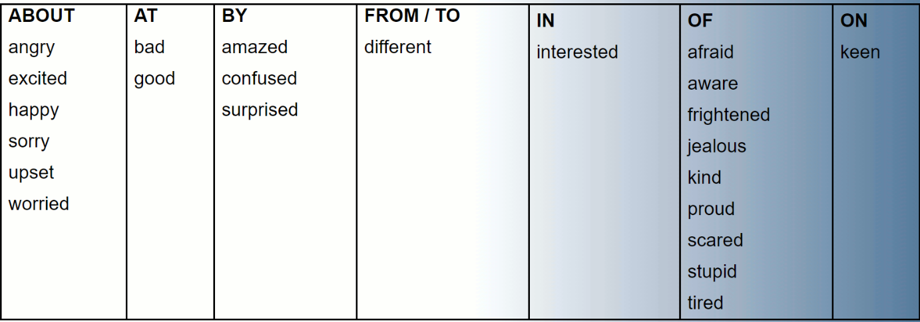
Exercise 1. Fill in the gaps with the correct preposition.
- A: Are you any good___chess? B: No, not really. I always lose.
- Football and advertisements! I’m really fed_____television these days.
- I can’t believe it. Carlos is afraid______pigeons. It’s ridiculous.
- Pedro has a problem. He’s jealous____everything, even his own sister!
- Carla is very worried____her exams.
- I get confused_____all this new technology.
- That was very stupid____him.
- Are you aware___situation in Australia?
- She’s very excited_____her trip to Egypt.
- I’m very bad____tennnis.
- My brother ate my chocolate cake. I was very angry___it.
- I’m very interested____nature and the environment
- My sister is very keen____golf.
- I’m tired___playing computer games all day.
- Hobbits are different____dwarves.
Exercise 2. Correct the mistakes.
- She felt terribly anxious for have to sing in front of such a large audience.
- I’m always glad for an opportunity to go to Paris. I’m particularly keen about go to the museums.
- You will be answerable for the court with any lies you have told.
- After she lost her job, Jean spent months feeling sorry about herself. But she was good to hide her emotions, and nobody realized how unhappy she was.
- Peter is certainly capable of do the job, so he should take it if he thinks it’s right about him.

Third week
Adjectives + that clause or to-infinitive. UNIT 87
Exercise 1. Create 10 sentences using the that clause. Use the example adjectives on UNIT 87.
Exercise 2. Put the sentences in to the correct order.
- due / your flight/is/What time/to arrive?
- We/this year./ another pay rise/unlikely/are/to get.
- that /hear/to/relieved/her exams./Emily/was/all/she had passed.
- a good job/is/to find/It/hard/nowadays.
- it/ online? / possible/ train tickets/ is / to buy
- was wrong/ to borrow/ George/ car/ asking./ without/ his father’s
- that/ You are/ to think/ foolish/ will be/ okay./ everything
- to reduce/ any further./ is/ impossible/ its prices/ It/ for the school
- in public. / been/ to speak/ for me/ difficult/ It’s/ always
- It/ of you/ was/ to invite/ us / to your party./ very nice

Fourth week
Comparison with adjectives. Er/more, enough, sufficiently, too- UNIT 88
Exercise 1. Choose enough or sufficiently
- My sister is_____________prepared for the concert.
- There is more than___________rice to last us for the winter.
- The policies of the two companies were not___________different from one another.
- I have been bringing__________well designed clothes for the models for this month’s magazine shoot.
- They were comfortable___________at the hotel they stayed at. So, they gave them a good review.
- The company has been giving a good__________salary for their employees since last year.
- The problem isn’t____________important to cause us concern.
- Young adult aren’t given_____________information about politics.
- They felt confident__________about their new product.
- The gas leak was serious___________that the police evacuated the building.
Exercise 2. Correct the mistakes.
- He is the more handsome person I have ever seen.
- Chocolate is tastiest than candy.
- She is the most tallest person in the world.
- They are more closer than you think.
- Our school is the most bestest in town.

