**REMINDER:**

* **Write down the title of the passage as well as the date of the day, and make sure to answer with full sentences on your NOTEBOOK.**
* **Look for the new words from the dictionary, and create 1 correct sentence.**
* **Notebooks will be taken once school starts.**
* **Future grades will be determined by how you have completed your homework. So, MAKE SURE you do your homework!**

**First week**

**Read the passage below, complete the exercises**

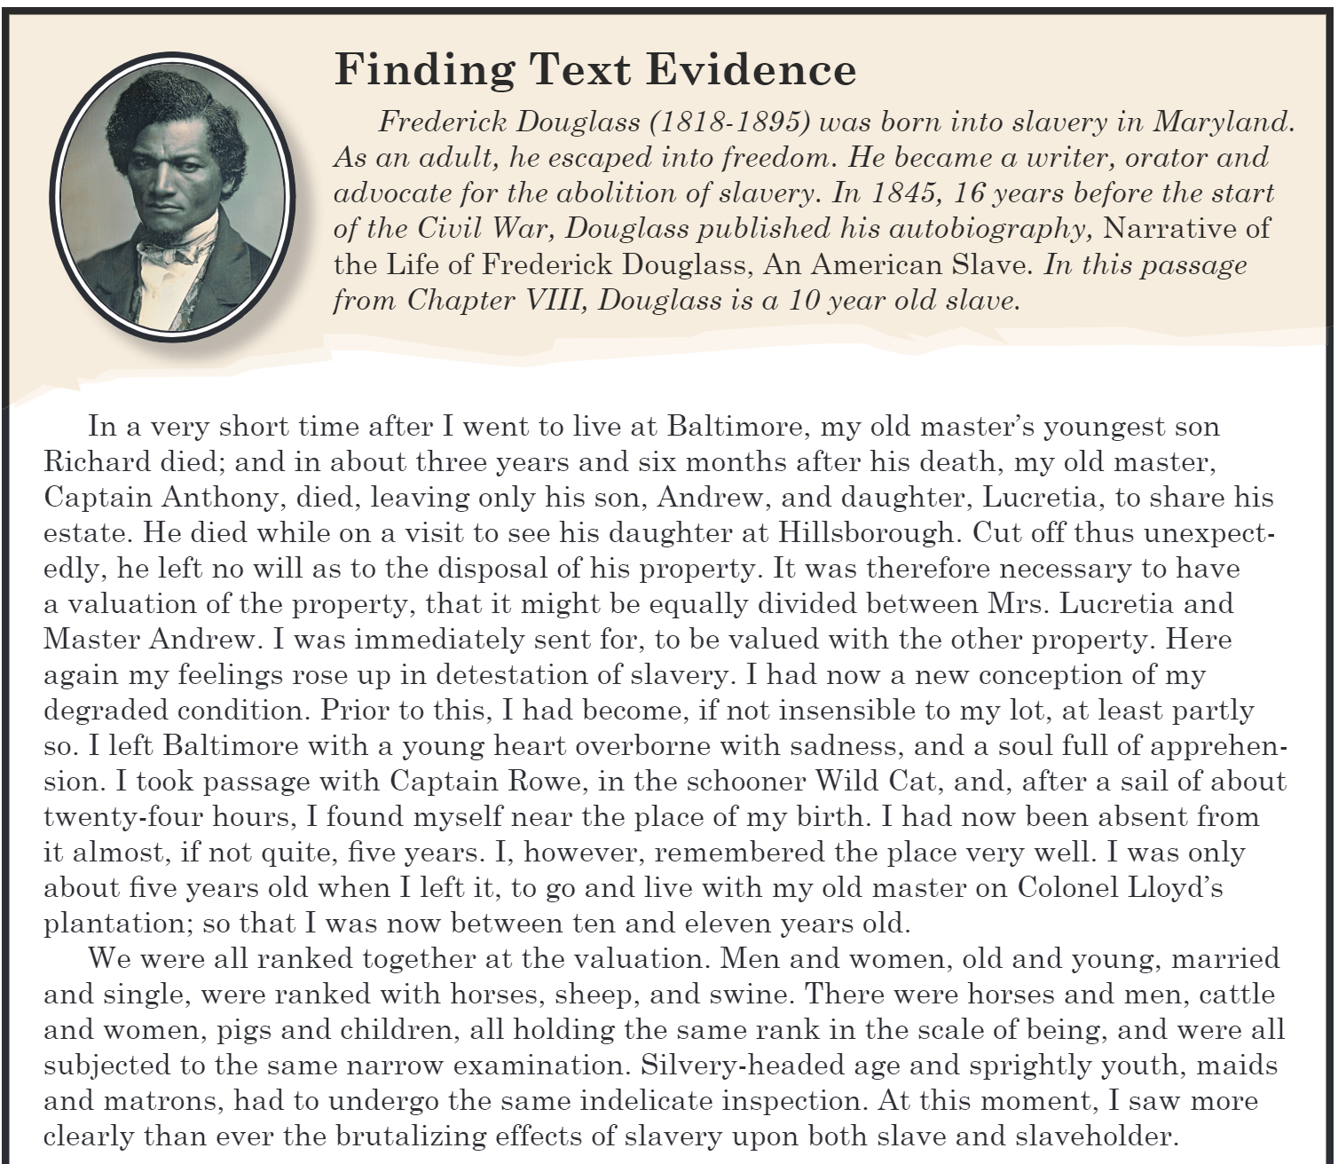

**Exercise 1.**

In the passage, Douglass explains that slavery was humiliating. Find an example from the text that most clearly supports this idea.

**New words:**

1. Estate
2. Disposal
3. Valuation
4. Detestation
5. Conception
6. Apprehension

**Second week**

**Read the passage below, complete the exercises.**

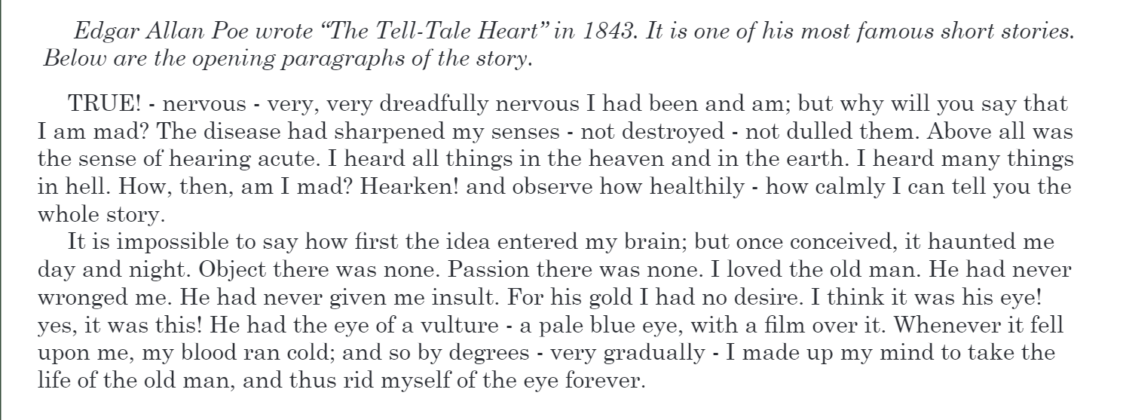

**Exercise 1. Find words from the passage that are closest in meaning to words below.**

**1st paragraph-**

1. Extremely-
2. Damage-
3. Examine-
4. Infection-
5. Relax-

**2nd paragraph-**

1. Absurd-
2. Frighten-
3. Affection-
4. Continuously-
5. Eliminate-

**Exercise 2. In this short story, the narrator claims that the he isn’t insane. But how does Edgar Allan Poe use language, punctuation and structure in the opening paragraphs to show that the narrator is, in fact, insane?**

**Third week**

**Read the passage below, complete the exercises.**

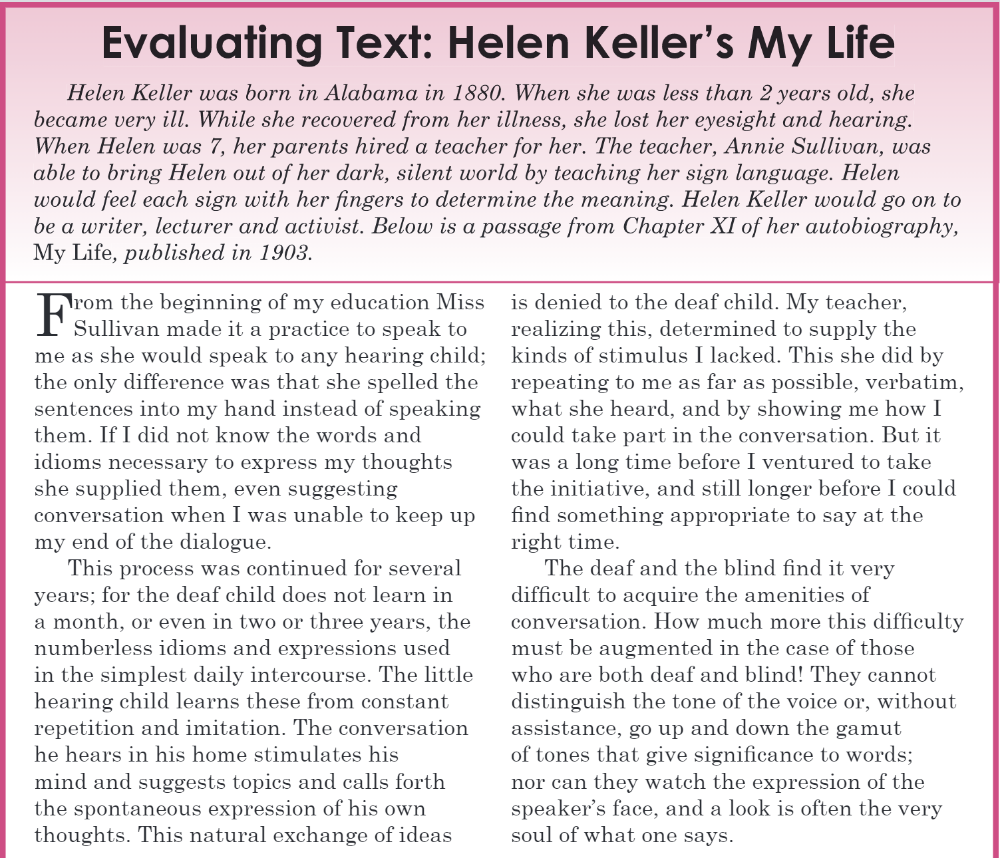

**Exercise 1. Find words from the passage that are closest in meaning to words below.**

**1st paragraph-**

1. Discrepancy
2. Crucial
3. Recommend
4. Communicate

**2nd paragraph-**

1. Plain-
2. Procedure
3. Mimicry
4. Encourage
5. Be without/not enough

**3rd paragraph-**

1. Achieve
2. Differentiate
3. Help
4. Spirit

**Exercise 2. In the text, Helen Keller claims that it is more difficult for hearing impaired children to learn to converse with others. Do you think her claim is correct? Does she give good reasons for her statements? Explain your answer.**

**Fourth week**

**Read the passage below, complete the exercises.**

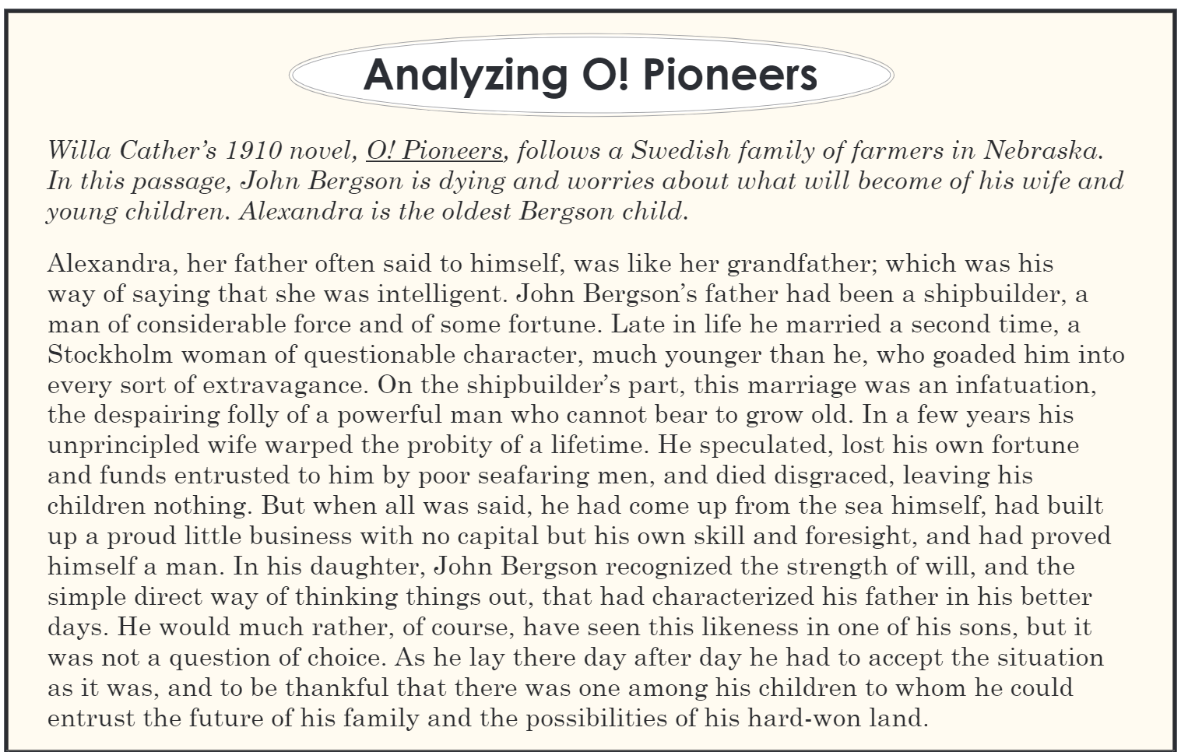

**Exercise 1. Alexandra shares personal qualities with her grandfather. What are these qualities and how will they help the Bergson family survive after her father dies? Find text examples to support your ideas.**

**Exercise 2. Find out the meaning of the new words from the dictionary and write 1 correct sentence.**

1. Considerable
2. Extravagance
3. Infatuation
4. Probity
5. Speculate
6. Foresight