Week-1 Subject: Grammar Unit 7- Do you…? (Present simple questions)
Explanation (Тайлбар): Дасгал хийдэг дэвтэр дээрээ хийнэ.
Exercise 1: Make present simple questions.(Present simple цагийг ашиглан асуух өгүүлбэр зохионо.) For example (Жишээ нь): She likes chocolate – Does she like chocolate?
- You finish school at 3.30 pm.
- He gets up at 5 am.
- It barks very loudly.
- They go to school by bus.
- I do exercises every morning.
- You learn Chinese on Fridays.
- He draws beautiful pictures.
- We go to the library.
- Tom plays tennis.
- I want to be famous.
Exercise 2: Page 23, exercise 2- Хуудас 23 дасгал 2.
Дасгалын заавар: Өгөгдсөн үгсийг ашиглаад Present simple цагаар асуух өгүүлбэр бүтээнэ. Жишээ нь:
(Where/live/your/parents?)- Where do your parents live?
Exercise 3: Complete the sentences do/don’t/does/doesn’t. do/don’t/does/doesn’t ашиглан өгүүлбэрүүдийг гүйцээнэ үү.
- _______you like Jane? Yes, I _____.
- _______Sally like reading? No, she____.
- _______John play handball every Thursday? No, he___.
- _______you like writing letters? No, I____.
- _______Paul like skate-boarding? No, he____.
Week-2 Unit 8- Present continuous and present simple
Ex1: Read and circle True or False. Уншаад үнэн худлыг дугуйлна уу.

- I play tennis every Saturday and Sunday. TRUE/FALSE
- I’m playing tennis now. TRUE/FALSE
- I play basketball every day. TRUE/FALSE
- I’m using the computer now. TRUE/FALSE
- My sister is watching TV now. TRUE/FALSE
Ex2: Do we usually use these words with the present simple or present continuous? Write them in the correct group. Доорх үгсийг зөв баганад ялгана бичнэ үү?
every day | now | on Mondays | right now | always
usually | sometimes | at the moment | never | every weekend

present simple | present continuous
Ex3: Write and draw! Write about what you do every day. Then write about what you are doing now. Draw a picture! Every day I ....................
Өөрийн өдөр бүр хийдэг зүйл болон яг одоо хийж буй зүйлээ бичээрэй. Зураг мөн зураарай.
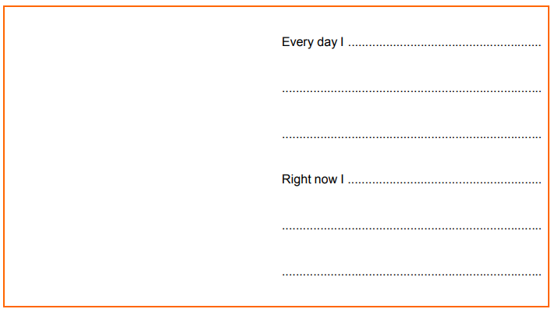

Week-3 Unit 9- I have…/ I’ve got…
Ex1: Read and find the toys and write them in the boxes.
skateboard
Ex2: Write questions. Асуулт зохиож бичнэ үү.
Example: (Julia / an umbrella?)- Has Julia got an umbrella?
- (you / a book?) ….................................
- (you / a passport?) ……………………..
- (your father/a car?)……………………
- (how much money/we?)………………….
- (What/kind of car/Sam?)…………………
Ex3: Page 27, exercise 9.5 27 хуудасны 5-р дасгалыг хийнэ үү. Have/has got эсвэл haven’t/ hasn’t got-г хүснэгтэнд өгөгдсөн үгсийн хамт ашиглан өгүүлбэрүүдийг гүйцээн бичнэ.
Week-4 Unit 10, 11, 12
Ex1: Write these questions in the past. Доорх өгүүлбэрүүдийг өнгөрсөн цагаар хувирган бичнэ үү. Example(Жишээ):
-Is it dark when she gets up in the morning?
-Was it dark when she got up in the morning?
- Does she buy the newspaper in the shop over there?
……………………………………………………...
- Do they have a good holiday?
...................................................................................
- Do they find any animal in the forest?
...................................................................................
- Do they do their homework in the evening?
...................................................................................
Ex2: Write questions in the past with these words.
Өгөгдсөн үгсийг өнгөрсөн цагийн хамт ашиглаад өгүүлбэр зохионо уу.
- when / study English / you .........................................................?
- what / do / yesterday / she .........................................................?
- like / the film / he .........................................................?
- live / in Paris / your parents .........................................................?
- walk / down / the road / they .........................................................?
Ex3: Write past simple of these verbs. Доорх үйл үгсийн өнгөрсөн цаг дээрх хэлбэрийг бичнэ үү. Example (Жишээ): tell-told
begin |  | fall
sell |  | speak
think |  | write
ring |  | win

