“HEALTH TECHNOLOGY-INTERNATIONAL EXPO” Guidance for participants

1. Organizations and enterprises must have obtained ATA CARNET, an international customs document, for goods, equipment and materials participating in the Exhibition from the Chamber of Commerce of their country.
2. Fill out the ATA CARNET in English. If it is filled in language other than English, the customs authority has the right to require a translation.
3. It is strictly prohibited to correct or change the information contained in the ATA carnet in the issuing country after entering the territory of Mongolia
4. It is strictly forbidden to buy and sell medicine and medical devices and medical equipment which participating in the exhibition.
5. Medicines, medical devices and medical equipment that participating in the exhibition will be returned from the territory of the country within the period determined by the customs authority of the country which was temporarily entered. In case of non-issue, the import customs tax will be imposed in accordance with the customs laws and regulations of the country, as well as the overdue penalty will be also imposed.
6. In case of medicine, medical devices and medical equipment that is participating in the exhibition, if they are not returned from the territory of the country, if they are stolen or exterminated, they will be imposed tax from customs of the country. If it was stolen it is necessary to obtain a police or customs statement document.
7. If the ATA carnet was not obtained, customs clearance shall be carried out using code 500 of the ”Procedure for the Temporary Entry of Goods into the Customs Territory” approved by Appendix No. 3 of the “Procedure for implementation of the Procedure for the Entry of Goods for Domestic Use” approved by Order No. A/40 of 2016 by Head of the General Department of Customs and Taxation.
8. Please notice that you must bring medicine, medical devices and medical equipment for the exhibition by 21st September of 2023, and be fully placed by 22th September at 09.00 a.m.
9. Security service of “Misheel expo” LLC will ensure the safety of large-sized equipment that will be displayed in the exhibition, while safety of small-sized equipment and materials will be ensured by the participant organization.
10. Things to consider when bringing equipment and merchandises through the cargo door of “Misheel expo” international trading center.

* During loading baggage and cars through the door, do not damage metal structure of the door, stone floor and the walls. In case of damage the individuals and enterprises will be responsible.

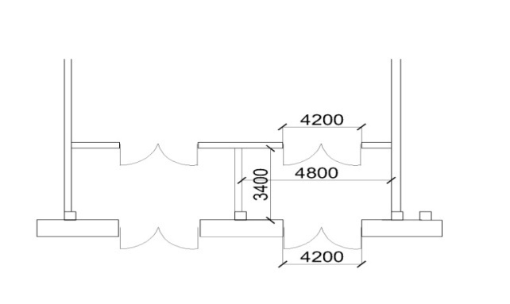Door height: 2.3m wide: 2.3m

Distance between the doors: 3.4m x 4.8m

Floor bearing capacity: 1tonn

1. Requests to increase the size of the exhibition stand area will be received until 8th Of September and will not be accepted if it is exceeded.

ATA CARNET MEMBER COUNTRIES

1. ALBANIA (AL)
2. ALGERIA (DZ)
3. ANDORRA (AD)
4. AUSTRALIA (AU)
5. AUSTRIA (AT)
6. BAHRAIN (BA)
7. BELARUS (BE)
8. BELGIUM/LUXEMBOURG (BE)
9. BOSNIA AND HERZEGOVINA (BA)
10. BRAZIL (BR)
11. BULGARIA (BG)
12. CANADA (CA)
13. CHILE (CL)
14. CHINA (CN)
15. COTE D’LVOIRE (CI)
16. CROATIA (HR)
17. CYPRUS (CY)
18. CZECH REPUBLIC (CZ)
19. DENMARK (DK)
20. ESTONIA (EE)
21. FINLAND (FI)
22. FRANCE (FR)
23. GERMANY (DE)
24. GIBRALTAR (GI)
25. GREECE (GR)
26. HONG KONG, CHINA (HK)
27. HUNGARY (HU)
28. ICELAND (IS)
29. INDIA (IN)
30. IRAN (IR)
31. IRELAND (IE)
32. ISRAEL (IL)
33. ITALY (IT)
34. JAPAN (JP)
35. KOREA (REP.OF) (KR)
36. LATVIA (LV)
37. LEBANON (LB)
38. LITHUANA (LT)
39. MACAO, CHINA (MO)
40. REPUBLIC OF MACEDONIA (MK)
41. MADAGASCAR (MG)
42. MALAYSIA (MY)
43. MALTA (MT)
44. MEXICO (MX)
45. MAURITIUS (MU)
46. MOLDOVA (MD)
47. MONGOLIA (MN)
48. MONTENEGRO (ME)
49. MOROCCO (MA)
50. NETHERLANDS (NL)
51. NEW ZEALAND (NZ)
52. NORWAY (NO)
53. PAKISTAN (PK)
54. POLAND (PL)
55. PORTUGAL (PT)
56. ROMANIA (RO)
57. RUSSIA (RU)
58. SENEGAL (SN)
59. SERBIA (RS)
60. SINGAPORE (SG)
61. SLOVAK REPUBLIC (SK)
62. SLOVENIA (SI)
63. REPUBLIC OF SOUTH AFRICA (ZA)
64. SPAIN (ES)
65. SRI LANKA (LK)
66. SWEDEN (SE)
67. SWITZERLAND (CH)
68. THAILAND (TH)
69. TUNISIA (TN)
70. TURKEY (TR)
71. UKRAINE (UA)
72. UNITED ARAB EMIRATES (AE) U
73. NITED KINGDOM (GB)
74. UNITED STATES (US)
75. UKRAINE (UA)