ADVICES ON THE PREPARATION FOR SUBMISSION TO ICASE
ICASE FIRST1, ICASE SECOND2, AND ICASE THIRD2†

1Department of Mathematical Sciences, Name of University, Country
E-mail address: icase-1@icase.mn
2Department of Mathematical Sciences, KSIAM Second University, South Korea
E-mail address: {icase-2, icase-3}@icase.mn

Abstract. For the preparation of a new manuscript, the following instructions should be followed closely. Manuscripts that are submitted in technically unsuitable form have to be returned for retyping or will be cancelled if the volume otherwise cannot be finished in time.
1. Introduction
This template can be used to prepare manuscripts for ICASE. You can download this template file from the homepage of ICASE (URL: http://icase.mn).
For the preparation of a new manuscript, using A4-sized papers is highly recommended. The paper title with Times New Roman should be centered and bold faced in 12-point font. For the main text, please use 11-point Times New Roman. First-order headings (sections) should be 12-point capital Times New Roman, centered, and enumerated using Arabic numbers. Second-order headings (subsections) should be 11-point Times New Roman, left aligned, and enumerated. All paragraphs are indented. For this Latex template, whenever you insert a blank line, your new paragraph is automatically indented.
2. Equations And Theorems
2.1. Equations. Equations should be centered. Please use Arabic numbers for numbering of equations. An example is as follows:
(2.1)

2.2 Theorems. Here is an example for theorems.
Theorem 2.1. This is a test theorem format.
Proof. The proof of Theorem 1 is put here. □
Here goes a corollary of the theorem.
Corollary 2.2. This is a corollary.
3. Figures and Tables
Figures and tables should be centered. Both figure and table captions should be Times New Roman, and enumerated using Arabic numbers. Examples are as follows:

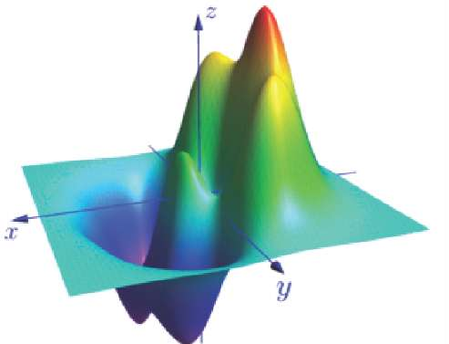
Figure 1. A sample figure caption

Table 1. A sample table caption.
Data 1 | Data 2 | Data 3 | Data 4 | Data 5
Value 1 | Value 2 | Value 3 | Value 4 | Value 5

Acknowledgments
A brief acknowledgment section may be put between the last section of the main text and reference section. References need to be numbered as they appear in the manuscript ([1], [2], [3], etc.) and should appear in the reference section in numerical order. The required format for references is as follows.
References
[1] X. Xie and M. Mirmehdi, RAGS: Region-Aided Geometric Snake, IEEE Transactions on Image Processing, 13 (2004), 640-652. (Reference format for journal papers)
[2] D. Gil and P. Radeva, Curvature vector flow to assure convergent deformable models for shape modeling, Lecture Notes in Computer Science, Springer Verlag, Proceedings of EMMCVPR, Lisbon, Portugal 2003. (Reference format for conference proceeding papers)
[3] G. Aubert and P. Kornprobst, Mathematical problems in image processing, Applied mathematical sciences 147, Springer Verlag, New York, 2002. (Reference format for books)

